**Source Code of Longest Increasing Sequence**

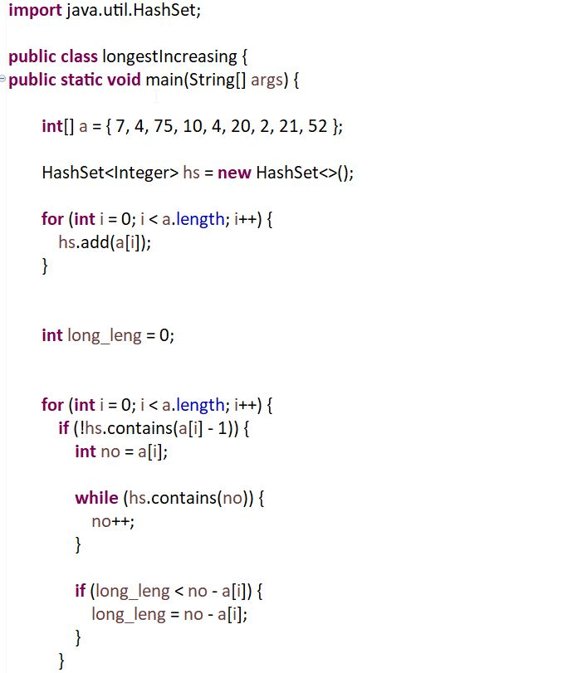 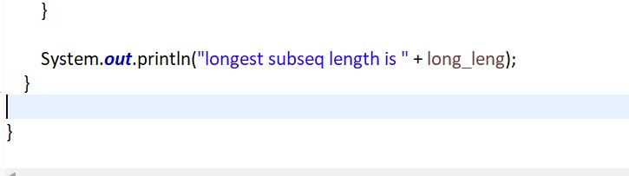**g Sequence**